Backups are monitored and failures are identified and handled via incident management

1. Open the snow link

<https://atosglobal.service-now.com/navpage.do>

1. Open the incident queue for MPC back up related open tickets

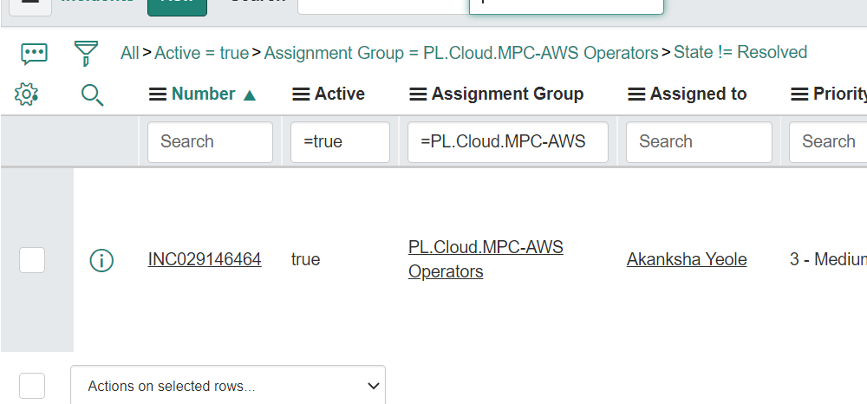

3.Open the incident queue for Philips back up related open tickets

